2019 Arts and Craft Show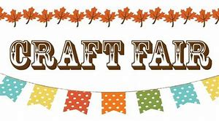

Benefits 2019 NYC student trip and 2020 Italy trip

October 5th, 2019
9AM – 3PM
The Bellamauro in Reynoldsville, PA

Crafter__________________________________________________________________
Address_________________________________________________________________
City/State/Zip____________________________________________________________
Business Name/Partner ____________________________________________________
Phone (home/cell) ___________________________ (work) _______________________
E-mail Address __________________________________________________________
Description of craft and booth _______________________________________________
________________________________________________________________________
Booth Space Pricing: $30/Table $35/Table with Electricity

[ ] (1) 6 ft Rectangular Table
[ ] Electricity

Space is allocated on a first come first served basis. You may make a request and we will do the best we can to accommodate you. The doors will be open @ 7:00AM for vendors to come set up displays. No refunds and no more than 2 tables per vendor.

Make checks payable to Melissa Mulhollan. Return your completed registration form with payment to:

Jeff Tech
Attention: Melissa Mulhollan
576 Vo-tech Road
Reynoldville, PA 15851

Any further questions, please call the Melissa Mulhollan, 814-590-7904 or 814-653-8265. Ext.161 or email at mtmulhollan@jefftech.us

Food will be sold on the premises—catered by The Bellamauro

*We ask that you bring one item to raffle off in a Chinese Auction that will take place the day of the craft show.

Thank you!

