“WALK WITH THE SHEPHERDS”
Beechwoods Presbyterian Church
14 Beechwood Road, Falls Creek, PA

Saturday, December 6th
10 a.m. to 12 Noon

Come take an “indoor” walk among the shepherds
anytime between 10 a.m. and 12 Noon
for a morning of creative fun for all ages.
Free & Open to the public.
Any questions please call 814-371-2981 (leave message)
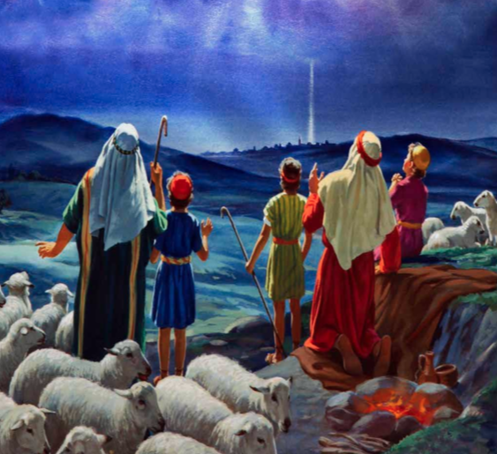
All are invited to a live event where “shepherds” tell about
the birth of Jesus Christ in their own words and through various stations that recount the events recorded in the Bible through drama, engage people of all ages in hands-on activities like crafting an ornament and playing music or singing,
and invite all to join in refreshments.
This event takes place indoors.

